ixium
8GB Water Resistant Spy Watch
User Manual

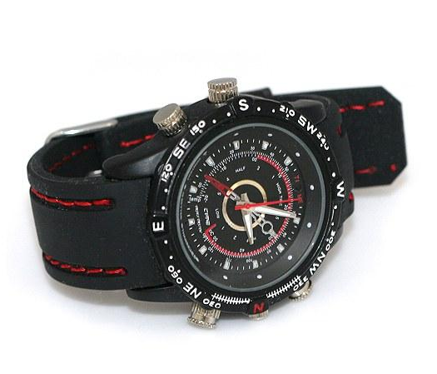
Contents
Package Contents 2
Before You Start 2
Overview 3
Controls 3
Set Time 3
USB: Syncing and Charging 3
Microphone 3
Power/Control And Mode 4
Camera Mode 4
Video Mode 4
Audio Mode 4
Timestamp Edit 5
Still Struggling? 7
Recommended 7
Other 7

Package Contents
- 8GB Water Resistant Spy Watch
- USB Cable (USB to 2.5mm jack)
- Spare Water Resistant Cap for Microphone

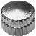
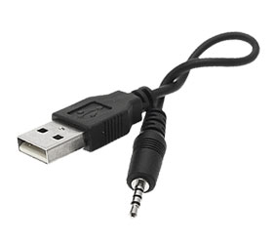

Before You Start
Make sure you have charged the device for 8 or more hours prior to use.
It is recommended that you charge for at least 24 hours; however we know this is not always possible.
Turn over for charging instructions…

Overview

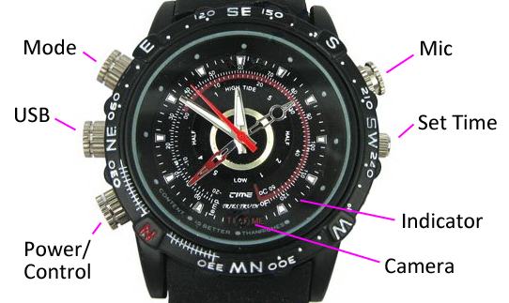
Figure 1
Figure 1 shows the controls that the watch uses. Nothing appears out of the ordinary, it looks and works just like a standard analogue watch. However it is packed full of useful features which enable anyone to monitor and record events.

Controls

Set Time
The set time button works just like a normal watch, pull out and set the time accordingly by twisting clockwise or anti-clockwise.

USB: Syncing and Charging
This button is actually a cap. To unscrew the cap, twist it anti-clockwise, you are now able to insert the USB cable that is supplied with the watch to charge the internal battery and transfer the files that are saved on the watch.
When you are not using the USB cable put the cap back on by screwing it clockwise.

Microphone
The microphone works just like any other; it will capture the sound for the videos and audio recorder. Included in the package is an extra cap so the watch can be made water resistant. Simply screw the microphone cap off like you did with the USB port and switch to the spare waterproof cap.

Power/Control And Mode
These buttons enable you to switch between the camera, video and audio recorder features depending on what you need.

Camera Mode
Press and hold the Power/Control button until you can see the indicator has turned red (this should only take 2 or 3 seconds). When the watch is ready to take photos this light will turn blue. Once the indicator has turned blue then all you need to do is point the watch in the direction you wish to take a picture of and quickly press the mode button. The indicator will turn red whilst the picture is taking and then turn blue again when ready to take the next one.
When you are done taking pictures press and hold the Power/Control button until you can see the indicator flashing red (this should only take 2 or 3 seconds). After the indicator has flashed red the camera is now off.

Video Mode
Start off by going into the camera mode. Instead of quickly pressing the mode button, quickly double press the Power/Control button and the blue light will flash. The indicator light will go out and might look like the watch it not doing anything, however, it is now recording video.
You can check whether it is still recording video by quickly pressing the mode button and the indicator light should flash blue again.
When you are done recording video press and hold the Power/Control button until you can see the indicator flashing red (this should only take 2 or 3 seconds). After the indicator has flashed red the video recorder is now off.

Audio Mode
Start off by going into the camera mode. Instead of quickly pressing the mode button, press and hold it until the indicator flashes red. The indicator light will go out and might look like the watch it not doing anything, however, it is now recording sound.
You can check whether it is still recording audio by quickly pressing the mode button and the indicator light should flash red again.
When you are done recording audio press and hold the Power/Control button until you can see the indicator flashing red (this should only take 2 or 3 seconds). After the indicator has flashed red the audio recorder is now off.

Timestamp Edit
You may need to update the internal clock for the timestamp shown in images and videos.
To do this, you will need to create a Text file with the date and time.
- Plug the watch into your computer by using a USB cable.
- It will appear as a Removable Disk.
- Open the Removable Disk; you might have some folders and a text file called “time” already there.
- If you already have the text file then move onto Step 7.
- Right click in the white space and a menu will appear (Figure 3), move down to “New” and select “Text Document”.

Figure 2
- A new Text document will appear (Figure 4) and give you the option to name it, call it “time”.
Figure 3
- Open this time file and write the date and time in the following method:
2012-05-19 09:46:11
- Save and close the file.
- Unplug the watch from the computer and turn it on. The time is now updated.
- Plug the watch back into your computer and delete the text file if still there.

Still Struggling?
If you are still struggling to understand how this item works you can get in contact via the following methods.

Recommended
Contact the official stockist through the eBay or Amazon messaging system.

Other
Email: support@ixium.co.uk
Telephone: 0115 8716899

