ixium
Compass Sports Cam F8
User Manual
Contents
Package Contents 2
Before You Start 2
Overview 3
Controls 3
Viewing Media 3
Charging the Camera 3
Modes 4
Video Mode 4
Photo Mode 4
Timestamp Edit 5
Still Struggling? 7
Recommended 7
Other 7

Package Contents
- Compass Cam
- USB Cable
- Carabiner
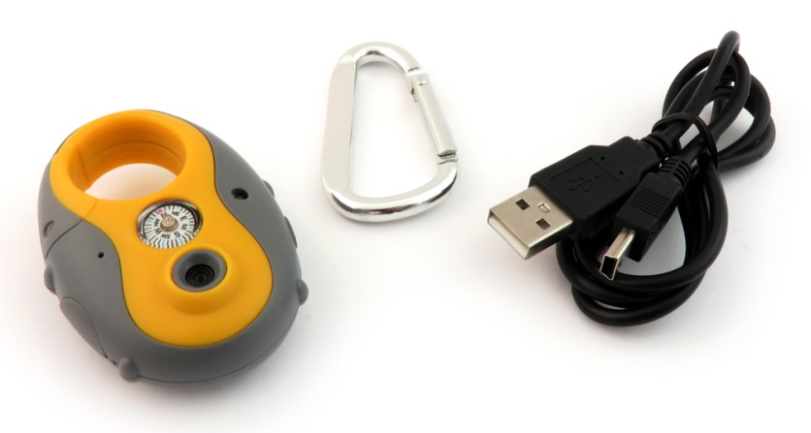

Before You Start
Make sure you have charged the device for 8 or more hours prior to full use.
It is recommended that you charge for 24 hours; however we know this is not always possible.
Turn over for charging instructions…

Overview
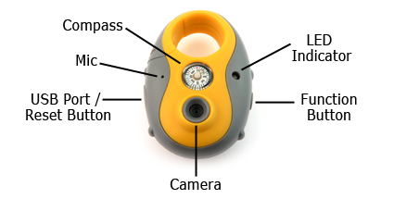
Figure 1
Figure 1 shows the controls that the camera uses.

Controls

Viewing Media
- Make sure the device is switched off (no lights should be on) and plug the device into a PC or laptop using the USB cable provided.
- The camera will come up as a removable drive (much like a USB memory stick).
- Under general options choose “open folder to view files”.
- Inside are folders labelled “Image” and “Video” where your files will be.

Charging the Camera
When charging the camera it is best to use a mains adapter like the one you might get with a mobile phone (see figure 2). The light will flash blue and red simultaneously whilst charging. Once the device has stopped charging the light will stay red.
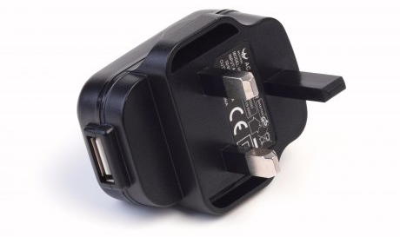
Figure 2

Modes
The camera is equipped with two modes:
- Video
- Photo

Video Mode
- When the device is switched off press and hold the function button for 2-3 seconds. The indicator should turn blue; keep holding for another 2-3 seconds before releasing.
- When ready the indicator will start flashing red which means the device is recording video.
- To stop recording press and hold the function button for around 2-3 seconds and the indicator should flash blue and red simultaneously and go off.

Photo Mode
- Follow steps 1 and 2 from the video mode.
- When the device is recording press the function button once and the light should stop red.
- Double tap the function button to change the mode from video to photo mode. The light will then turn blue.
- When the light is blue press the function button once and the blue light will flash twice. You will then have taken a picture.
- To exit photo mode double tap and the camera will go back to recording.
…OR
- To turn off press and hold the function button for around 2-3 seconds and the indicator should flash blue and red simultaneously and go off.

Timestamp Edit
You may need to update the internal clock for the timestamp shown in videos.
To do this, you will need to create a Text file with the date and time.
- Plug the camera into your computer by using a USB cable.
- It will appear as a Removable Disk.
- Under general options choose “open folder to view files”.
- Right click in the white space and a menu will appear (Figure 3), move down to “New” and select “Text Document”.

Figure 3
- A new Text document will appear (Figure 4) and give you the option to name it, call it “SysTime”.
Figure 4
- Open this SysTime file and write the date and time in the following method:
2014-12-10 10-10-59 (Year-Month-Day Hour-Minute-Seconds)
- Save and close the file.
- When you capture video and view it on your computer the time should be updated.

(next page)

Still Struggling?
If you are still struggling to understand how this item works you can get in contact via the following methods.

Recommended
Contact the official stockist through the eBay or Amazon messaging system.

Other
Email: support@ixium.co.uk
Telephone: 0115 8716899

