ixium
DVR Clock X520
User Manual

Contents
Package Contents 2
Before You Start 2
Overview & Basic Setup 3
Indicators 3
Battery and Charging 3
Set Time 3
Inserting the Memory Card 3
Reading the Memory Card 3
Operation Instructions 4
Turn the clock on and off 4
Recording a video 4
Taking a picture 4
Recording audio 4
Timestamp Edit 5
Still Struggling? 6
Recommended 6
Other 7

Package Contents
- DVR X520 Clock
- USB Cable (USB to Mini USB)

Before You Start
Make sure you have charged the device for 8 or more hours prior to use.
It is recommended that you charge for at least 24 hours; however we know this is not always possible.
You must insert a MicroSD or MicroSDHC memory card with free space before using this device
Turn over for charging instructions…

Overview & Basic Setup
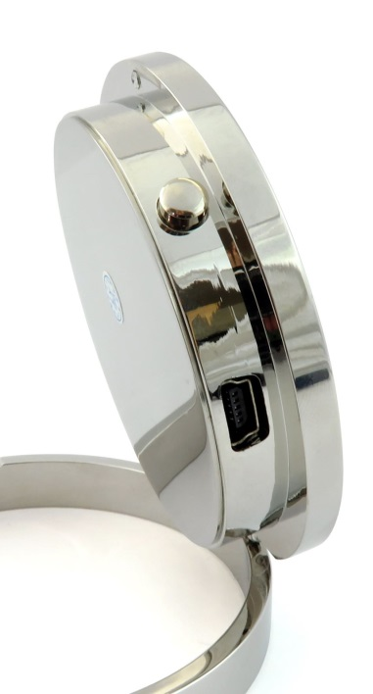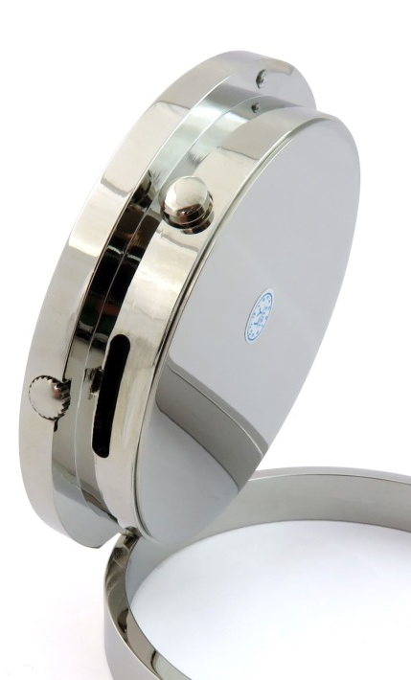
Power/Video
MicroSD Card Slot
Time adjustment
Photo/Audio
Mini USB port
Figure 1

Indicators
The LED indicator is located underneath the number 6.

Battery and Charging
Supplied with the clock is a USB cable which enables you to charge the internal battery. This can be done via a computer or a USB mains charger. Whilst on charge, the LED indicator will flash purple and blue.
Set Time
Pull out the time adjustment dial and rotate it to change the time on the clock. Whilst the dial is pulled out the clock will stop ticking. Push the dial back when you are finished and the clock will resume.

Inserting the Memory Card
For the clock to record any footage you must insert a Micro SD card in to the slot on the side; you can use any Micro SD card between 4GB and 32GB. If you need a Micro SD card then take a look here: www.wecostless.co.uk > electronics > memory cards
To insert a memory card into the device, with the clock facing you insert the memory card with the contacts facing you and push until it clicks into place.

Reading the Memory Card
Connect the clock via the included USB cable to a free USB port on your or computer laptop computer. You may see a message in the system tray about “Installing Device Drivers”. You will then see an “Autoplay” window open which will allow you to access the inserted memory card. If the autoplay window does not open it may be due to your settings. You can still access the memory card by going to “My Computer” and then double clicking the appropriate removable device.
If you are unsure which device is your card then do the following. Open the “My Computer” window and observe the contents. Plug in the clock and you will see the Removable Device appear in the window. Please allow up to 30 seconds for the device to appear.

Operation Instructions

Turn the clock on and off
Press and hold the Power/Video button for 3 seconds and let go. You see a purple LED - the clock is now in standby mode.
When the clock is on standby mode, press and hold the Power/Video buttons for 3 seconds and let go. The LED will go out - the clock is now off.

Recording a video
When the clock is on standby mode, press the Power/Video button once. The LED will flash purple and red and then go out, the clock is now recording a video. Press the button to stop recording, the LED will turn blue and the clock is now back in standby mode.
If you make another recording after this point, the LED will flash blue and turn off to indicate the clock is recording video.

Taking a picture
When the clock is on standby mode, press the Photo/Audio button. The LED will turn red, go off and come back on red, the clock has taken a picture. When the LED turns back purple, the clock is now back in standby mode.

Recording audio
When the clock is on standby mode, press and hold the Photo/Audio button. The LED will flash purple and blue and then go out, the clock is now recording a video. Press the button to stop recording and the LED will turn blue, the clock is now back in standby mode.

Timestamp Edit
You may need to update the internal clock for the timestamp shown in images and videos.
To do this, you will need to create a Text file with the date and time.
- Plug the camera into your computer by using a USB cable.
- It will appear as a Removable Disk.
- Open the Removable Disk; you might have some folders and a text file called “time” already there.
- If you already have a file called “time” then move onto Step 7.
- Right click in the white space and a menu will appear (Figure 3), move down to “New” and select “Text Document”.

Figure 2
- A new Text document will appear (Figure 4) and give you the option to name it, call it “time”.
Figure 3
- Open this time file and write the date and time in the following method:
2010-01-26 10:10:59 (this is example only, use the correct date/time)
- Save and close the file.
- Unplug the camera from the computer and turn it on. The time is now updated.
- Plug the USB Stick back into your computer and delete the time file if still there.

Still Struggling?
If you are still struggling to understand how this item works you can get in contact via the following methods.

Recommended
Email: support@ixium.co.uk

Other
Telephone: 0115 8716899

