ixium
iXium IXSW8 Spy Watch
User Manual

Contents
Package Contents 2
Before You Start 2
Overview 3
Controls 3
Change Time 3
USB: Syncing and Charging 3
Microphone 3
Power/Control 4
Power On 4
Video Mode 4
Photo Mode 4
Audio Mode 4
Power Off 5
Flow Chart of Watch Operation 5
Still Struggling? 8
Recommended 8
Other 8

Package Contents
- Spy Watch
- USB Cable (USB to 2.5mm jack)
- Spare Cap for Microphone

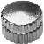
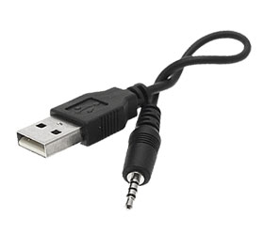

Before You Start
Make sure you have charged the device for a minimum of 12 hours prior to first use. This is to condition the battery and will help provide along and efficient lifespan.

Turn over for charging instructions…

Overview

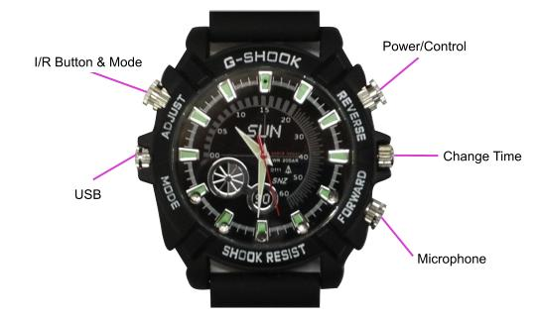
A
C
Figure 1 (appearance may vary – features do not)
Figure 1 shows the controls that the watch has. Nothing appears out of the ordinary, it looks and works just like a standard watch. However it is packed full of useful features which enable anyone to monitor and record events.

Controls

Change Time
The change time button works just like a normal watch, pull out and set the time accordingly by twisting clockwise or anti-clockwise.

USB: Syncing and Charging
This button is actually a cap. To unscrew the cap twist it anti-clockwise, you are now able to insert the USB cable that is supplied with the watch to charge the internal battery and transfer the files that are saved on the watch.
When you are not using the USB cable put the cap back on by screwing it clockwise.

Microphone
The microphone works just like any other; it will capture the sound for the videos and audio recorder.

Power/Control
When this device is turned on, it will go straight into video mode and begin recording. This enables you to start recording without messing around with multiple buttons.

Power On
Press and hold the Power/Control button to turn the unit on. The indicator will turn Blue and Red for around 2 seconds and then go out, the watch is now filming. If you wish to confirm what the watch is doing press the Power/Control button once and it will ‘blip’ the Blue light if it is recording. To stop recording press the Power/Control Button twice with approx. a 1/4 second interval to enter standby mode.
Standby Mode
There are 3 Standby modes indicated by a solid coloured light. By default, after turning the watch on and stopping recording you will be in Video Mode Standby. To change mode press the I/R Button and Mode button and it will move to the next mode. There are 3 modes in total and it will cycle through them, IE: after the 3rd mode it will return to the 1st. The sequence is (1st)Video Mode Standby -> (2nd)Photo Mode Standby -> (3rd)Audio Mode Standby.
Video Mode
After turning the watch on it will immediately start recording video. Stop it from recording by pressing the Power/Control button twice with approx. 1/4 second interval. You will see the indicator turn solid Blue. This indicates that you are in Video Mode Standby, in this mode you can stop and start video recordings. Press the Power/Control button to start a recording, and double press with a 1/4 second interval to stop and return to Video Mode Standby.
To turn on the IR function whilst in video mode, start a recording and then press and hold the I/R Button and Mode button to turn the IR LEDs on. The red light will flash 3 times to confirm they have been turned on. The IR LEDS can only be used in Video recording mode.
To move to next mode, press the I/R Button and Mode button and you will see the indicator change to Red.
Photo Mode
The solid Red indicator means that it is in Photo Mode Standby. A single press from the Power/Control button in this mode will make it take a photo. The Red indicator will go out and come back on after when ready to take the next.
To move to the next mode, press the I/R Button and Mode button and you will see the indicator change to Blue and Red.

Audio Mode
The solid Blue and Red indicator means you are in Audio Mode Standby. A single press from the Power/Control button will start the watch recording an audio file. Whilst recording the Blue and Red light will flash alternately. To stop recording press the Power/Control button once and the light will go back into Standby, indicated by the Blue and Red solid light.

Power Off
When you are done with the device, you can turn it off from any mode by pressing and holding the Power/Control button until you can see the indicator come on Blue and Red; hold for at least 2 seconds and then let go. The light will go out as you let go of the button and the device is now off.

Flow Chart of Watch Operation

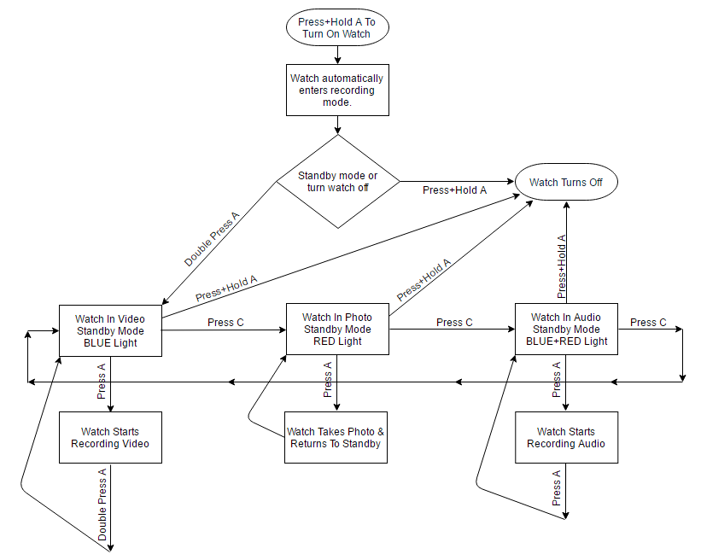
Timestamp Edit
You may need to update the internal clock for the timestamp shown in images and videos.
To do this, you will need to create a Text file with the date and time.
- Plug the camera into your computer by using a USB cable.
- It will appear as a Removable Disk.
- Open the Removable Disk; you might have a folder called DCIM and a text file called “time” already there.
- If you already have a file called “time” then move onto Step 7.
- Right click in the white space and a menu will appear (Figure 3), move down to “New” and select “Text Document”.

Figure 2
- A new Text document will appear (Figure 4) and give you the option to name it, call it “time”.
Figure 3
- Open this time file and write the date and time in the following method:
2012.01.24 13:30:30 (this is example only, use the correct date/time)

- Save and close the file.
- Unplug the camera from the computer and turn it on. The time is now updated.
- Plug the USB Stick back into your computer and delete the time file if still there.

Still Struggling?
If you are still struggling to understand how this item works you can get in contact via the following methods.

Recommended
Contact the official stockist through the eBay or Amazon messaging system.

Other
Email: support@ixium.co.uk
Telephone: 0115 9899516

