iXium Video Capture Device 2015
Ulead Video Studio SE DVD
Quick Setup Sheet
Thank you for your purchase of the iXium 2015 Plug & Play Video Capture Device. Please follow the steps below to get the device installed and if you have any trouble, please give our technical support team a call on 01158716899 and we’ll get you up and running in no time. We also have video tutorials for the device on our YouTube support channel: https://www.youtube.com/user/IxiumSupport

Setup Guide
- Insert the disc into your CD drive. You may be presented with the window below – select “Run autorun.exe”
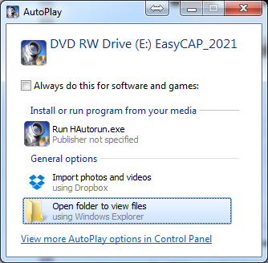

- The autorun menu will appear as pictured below, please select “Install Driver” and follow the onscreen instructions to install the driver. Once this has completed, select “Install Video Studio” and again follow the onscreen instructions. The serial code required during the installation is:
783A2-8A000-05520256
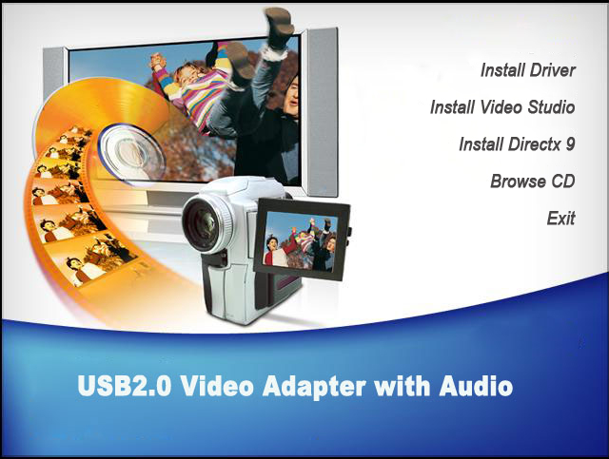

- Once completed you will be presented with an Icon on your desktop called “Ulead VideoStudio SE DVD”. DO NOT RUN THIS PROGRAM YET.

- Connect the capture device to your PC*. It will automatically install the drivers. This may take a few seconds to a few minutes depending on your system. You can check that it has completed installing the drivers by looking in device manager for “SMI Grabber Device” under the heading “Sound, video and game controllers”.
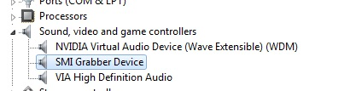
If it does not install automatically the driver can be located manually at C:\Program Files (x86)\Common Files\SoMagic\usbgrabber3c\ and then choose either the 32 or 64 bit folder.
- You can now run the “Ulead VideoStudio SE DVD” shortcut from your desktop shortcut that was created earlier.

- After running the shortcut you will be presented with a choice of “VideoStudio Editor” and “Movie Wizard”. Choose “Video Studio Editor” to load the required software. If you see a registration window, you can tick “Don’t show again” and click “Register Later” if you do not wish to see this message again. Registration is not required for any application functions or support from our team.
- In the window that is now open, click “Capture” as highlighted below:

- You will see some options towards the centre of the screen, select “Capture Video”. You may be presented with a window titled “Change Field Order”. This will complete automatically and once at 100% you can click ok and the window will disappear.
- You will now see the options as pictured below. Select “SMI Grabber Device” from the ‘Source’ list, and “DVD” from the ‘Format List’. Then click on the button marked “Options” with the picture of the cog to the left of it.
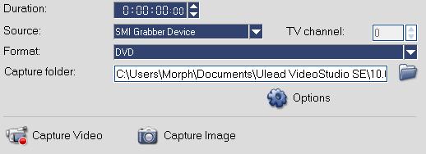
- On the options list, select “Video and Audio Capture Property Settings..”
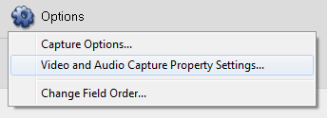
- In the window that opens, make sure “Input Source” is selected correctly (Video Composite = Red/White/Yellow cables, SVideo = Black Cable).
TV System should be set as the appropriate standard for your input device (IE PAL or NTSC).
Finally, ensure that you tick the box marked “Use PCI Audio”. This is extremely important, or you will not capture any audio from the input device. You can ignore the other 2 audio selection boxes as these will have no effect once “Use PCI Audio” is ticked.
Click Ok to save the settings. You may once again see the “Change Field Order” window which can again be dismissed once it completes.
You are now ready to start capturing videos! Click the “Capture Video” button to start capturing, and again to stop.
From here you can do anything you like with your videos using your favourite editing suite. You could upload them to YouTube or Facebook or even make your own DVD for which we recommend Windows DVD Maker. Just don’t forget to make the DVD in “Video Disc”mode and not “Data Disc”!

For more help email us at support@ixium.co.uk or you call our support team 01158716899. We also have a YouTube tech support channel: https://www.youtube.com/user/IxiumSupport

* If the driver does not install correctly, try connecting the device directly to your PC without using the small USB port extension cable, and also try a different USB port. If you continue to have issues installing the device itself please contact us using the details above.

