ixium
XLBW Lighter Camera
User Manual
Contents
Package Contents 2
Before You Start 2
Overview 3
Controls 3
SD Card Slot (TF) 3
USB: Syncing and Charging 3
Power / Capture 3
Turn On 3
Turn Off 3
Video Recording 4
Lighter Function 4
Torch Function 4
Timestamp Edit 5
Still Struggling? 7
Recommended 7
Other 7

Package Contents
- Lighter Camera

Before You Start
Make sure you have charged the device for 8 or more hours prior to full use.
It is recommended that you charge for 24 hours; however we know this is not always possible.
Turn over for charging instructions…

Overview
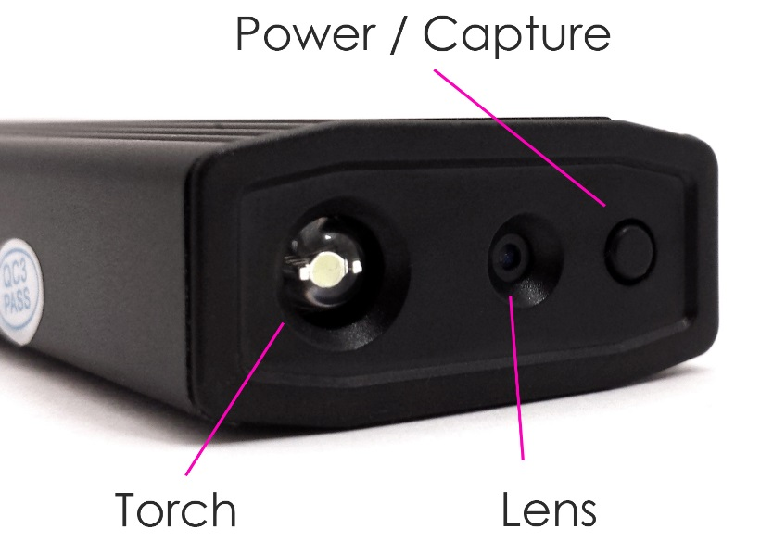
Figure 1
Figure 1 shows the controls that the Lighter Camera uses.

Controls

SD Card Slot (TF)
You are able insert a Micro SD card (TF) up to 32GB into the Lighter Camera.
Remove the cap from Lighter and you will see the Micro SD slot in front of the USB connector. Make sure the Micro SD card text is facing up so the contact points are facing down (Figure 2). The Micro SD Card should click in to place and sit flush to the edge of the Lighter.
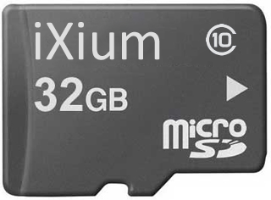
Figure 2

USB: Syncing and Charging
Remove the cap and plug the Lighter in to your PC or USB mains charger (not included), a blue light will come on, it will change to red once the charging process is completed.
To access the recordings on the Lighter; plug it into your PC, it will be recognised in the same way a USB memory stick would be. You can then transfer the recorded videos onto your PC.

Power / Capture

Turn On
Press and hold the Power / Capture button, there will be a short vibration and the blue indicator will come on (this should only take 2 or 3 seconds). The Lighter is now on a ready to use.

Turn Off
Press and hold the Power / Capture button, the indicator will flash quickly and go out (this should only take 2 or 3 seconds). The Lighter is now turned off.

Video Recording
Turn the Lighter on; quickly press the Power / Capture button once, the camera will vibrate twice and the indicator will go out, you are now recording a video. To end the recording just press the Power / Capture button again the camera will vibrate three times and the indicator will come back on solid.

Lighter Function
With the cap on the top of the lighter press and hold the lighter button, the filament will then light up and it can be used like you would a normal lighter.

Torch Function
Press the torch button on the side of the lighter, the torch LED at the bottom of the lighter will come on. To turn the torch off press the button again.

(turn over)

Timestamp Edit
You may need to update the internal clock for the timestamp shown in images and videos.
To do this, you will need to create a Text file with the date and time.
- Plug the camera into your computer by using a USB cable.
- It will appear as a Removable Disk.
- Open the Removable Disk; you might have some folders and a text file called “time” already there.
- If you already have a file called “time” then move onto Step 7.
- Right click in the white space and a menu will appear (Figure 3), move down to “New” and select “Text Document”.

Figure 3
- A new Text document will appear (Figure 4) and give you the option to name it, call it “time”.
Figure 4
- Open this time file and write the date and time in the following method:
2010-01-26 10:10:59 (this is example only, use the correct date/time)
- Save and close the file.
- Unplug the camera from the computer and turn it on. The time is now updated.
- Plug the USB Stick back into your computer and delete the time file if still there.

(turn over)

Still Struggling?
If you are still struggling to understand how this item works you can get in contact via the following methods.

Recommended
Contact the official stockist through the eBay or Amazon messaging system.

Other
Email: support@ixium.co.uk
Telephone: 0115 8716899

