ixium
Spy Key Fob
User Manual
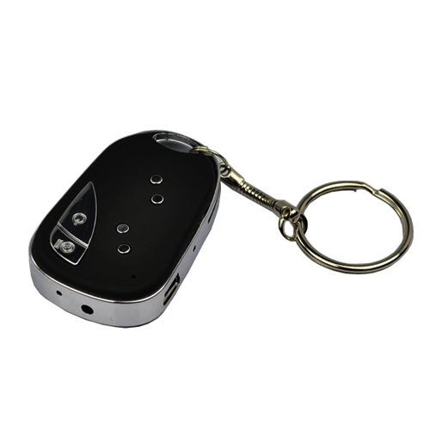

Contents
Package Contents 2
Before You Start 2
Overview 3
Controls 3
SD Card Slot (TF) 3
USB: Syncing and Charging 3
Power On/Off 4
Turn On 4
Turn Off 4
Capture/Mode 4
Camera Mode 4
Video Mode 4
Webcam Mode 4
Timestamp Edit 5
Still Struggling? 7
Recommended 7
Other 7

Package Contents
- Spy Black and Silver Key Fob
- USB Extension Cable
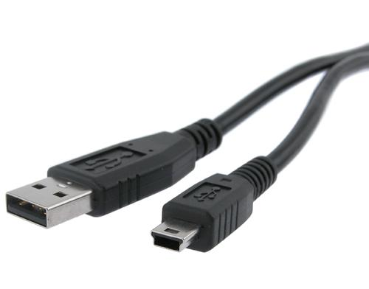

Before You Start
Make sure you have charged the device for 8 or more hours prior to full use.
It is recommended that you charge for 24 hours; however we know this is not always possible.
Turn over for charging instructions…

Overview

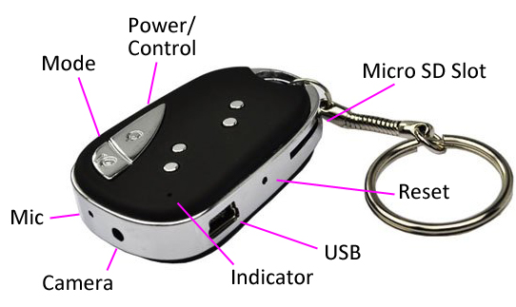
Figure 1
Figure 1 shows the controls that the key fob uses.

Controls

SD Card Slot (TF)
You are able insert a Micro SD card (TF) up to 32GB into this key fob.
When holding the key fob with the buttons on top, make sure the Micro SD card is facing down so the contact points are visible (Figure 2).
Figure 2

USB: Syncing and Charging
Supplied with the key fob is a USB cable which enables you to charge the battery and transfer the files that are saved on the Micro SD Card.

Power On/Off

Turn On
Press and hold the Power On/Off button until you can see the indicator has turned amber (this should only take 2 or 3 seconds).

Turn Off
Press and hold the Power On/Off button until you can see the indicator goes out (this should only take 2 or 3 seconds).

Capture/Mode
This button enables you to switch between the camera and video features depending on what you need.

Camera Mode
Turn the key fob on. Once the indicator has turned amber then all you need to do is point the watch in the direction you wish to take a picture of and quickly press the Capture/Mode button. The amber light will go out momentarily and come back when ready to take the next picture.
When you are done taking pictures you can turn the key fob off.

Video Mode
Turn the key fob on. Once the indicator has turned amber press and hold the Capture/Mode button and the indicator will then start flashing and then go out (this should only take 2 or 3 seconds). It is now recording video.
You can check whether it is still recording video by quickly pressing the Power On/Off button and the indicator light should flash amber again.
When you are done recording video press and hold the Capture/Mode button until you can see the indicator flash amber and then stay on solid (this should only take 2 or 3 seconds). The solid amber indicator means that it is no longer recording video. You can turn the key fob off or repeat either of the processes to capture a picture or video.

Webcam Mode
Webcam mode will capture sound and video like any other webcam.
Download the drivers/software from www.ixium.co.uk/downloads.php
It will download an application called Webcamdriver.exe. Install this program by double clicking on it and following the onscreen instructions.
Once installed, plug the key fob into your computer via the USB connection, press and hold Capture/Mode button for a little over 3 seconds and it will act as a webcam.
Simply load your chat software and enjoy.

Timestamp Edit
You may need to update the internal clock for the timestamp shown in images and videos.
To do this, you will need to create a Text file with the date and time.
- Plug the key fob into your computer by using the USB cable supplied.
- It will appear as a Removable Disk.
- Open the Removable Disk, you might have a folder called DCIM and a text file called TAG already there.
- If you already have a file called TAG then move onto Step 7.
- Right click in the white space and a menu will appear (Figure 3), move down to “New” and select “Text Document”.

Figure 3
- A new Text document will appear (Figure 4) and give you the option to name it, call it “TAG”.
Figure 4
- Open this TAG file and write the date and time in the following method:
2011-15-01 23:59:59 (this is example only, use the correct date/time)
- Save and close the file.
- Unplug the key fob from the computer and turn it on. The time is now updated.
- Plug the key fob back into your computer and delete the TAG file.

(next page)

Still Struggling?
If you are still struggling to understand how this item works you can get in contact via the following methods.

Recommended
Contact the official stockist through the eBay or Amazon messaging system.

Other
Email: support@ixium.co.uk
Telephone: 0115 8716899

