ixium
DVR Button Camera
User Manual

Contents
Package Contents 2
Before You Start 2
Overview 3
Controls 4
SD Card Slot (TF) 4
USB: Syncing and Charging 4
Microphone 4
On/Off 4
Video Mode 4
Camera Mode 5
Audio Mode 5
Timestamp Edit 6
Still Struggling? 8
Recommended 8
Other 8

Package Contents
- DVR Button Camera
- USB Cable (USB to Mini USB)
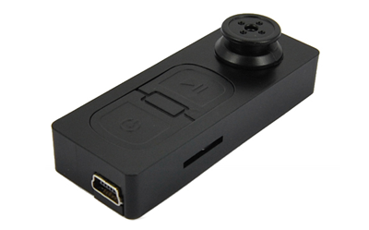

Before You Start
Make sure you have charged the device for 8 or more hours prior to use.
It is recommended that you charge for at least 24 hours; however we know this is not always possible.
Turn over for charging instructions…

Overview
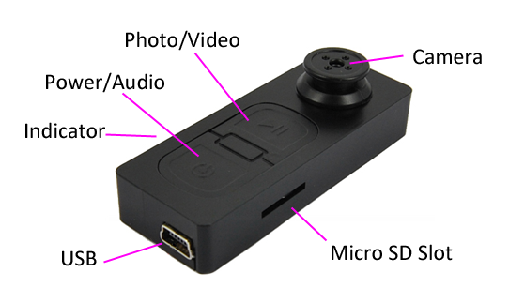
Figure 1
Figure 1 shows the controls that the button camera uses.

Controls

SD Card Slot (TF)
You are able insert a Micro SD card (TF) up to 32GB into this camera.
When holding the camera with the front facing you, make sure the Micro SD card is facing down so the contact points are visible (Figure 2).
Figure 2

USB: Syncing and Charging
Plug in a Mini USB cable to charger and Sync the files on the Micro SD card. When plugged in the indicator will light up red.

Microphone
The microphone works just like any other; it will capture the sound for the videos and audio recorder

On/Off
To turn on simply press and hold the power/audio button for 1-2 seconds and the indicator will light up red and vibrate for a few seconds. Wait until the button camera has stopped vibrating and you are ready to use the camera.
To switch the device off press both the power/audio and the photo/video buttons and the indicator will go out.

Video Mode
Turn the button camera on. When on the indicator should be red, press and hold the photo/video button and the indicator will flash red and quickly vibrate twice which means it is recording.
When you are done recording video quickly press the power/audio button and the red indicator will come back on solid.
You can turn the camera off or use one of the other features when done taking videos.

Camera Mode
Turn the button camera on. When on, quickly press photo/video button, the indicator will go out and vibrate once; when ready to take the next photo the indicator will light back up.
You can turn the camera off or use one of the other features when done taking photos.

Audio Mode
Turn the button camera on. When on, quickly press power/audio button. The button camera will vibrate 6 times quickly and the indicator will go out. This is now recording audio.
When you are done recording audio quickly press the power/audio button and the red indicator will come back on solid and quickly vibrate 3 times.
You can turn the camera off or use one of the other features when done taking audio.

Timestamp Edit
You may need to update the internal clock for the timestamp shown in images and videos.
To do this, you will need to create a Text file with the date and time.
- Plug the camera into your computer by using a USB cable.
- It will appear as a Removable Disk.
- Open the Removable Disk, you might have a folder called DCIM and a text file called “time” already there.
- If you already have a file called “time” then move onto Step 7.
- Right click in the white space and a menu will appear (Figure 3), move down to “New” and select “Text Document”.

Figure 3
- A new Text document will appear (Figure 4) and give you the option to name it, call it “time”.
Figure 4
- Open this time file and write the date and time in the following method:
2010.01.26 10:10:59 (this is example only, use the correct date/time) Save and close the file.
- Unplug the camera from the computer and turn it on. The time is now updated.
- Plug the USB Stick back into your computer and delete the time file if still there.

(next page)

Still Struggling?
If you are still struggling to understand how this item works you can get in contact via the following methods.

Recommended
Contact the official stockist through the eBay or Amazon messaging system.

Other
Email: support@ixium.co.uk
Telephone: 0115 9899516

