ixium
Badged Spy Key Fob
User Manual

Contents
Package Contents 2
Before You Start 2
Overview 3
Controls 3
SD Card Slot (TF) 3
USB: Syncing and Charging 3
Power 4
Turn On 4
Turn Off 4
Photo/Video 4
Camera Mode 4
Video Mode 4
Motion Detection Mode 4
Timestamp Edit 5
Still Struggling? 7
Recommended 7
Other 7

Package Contents
- Badged Spy Key Fob
- USB Extension Cable
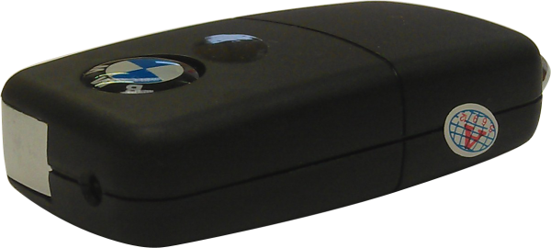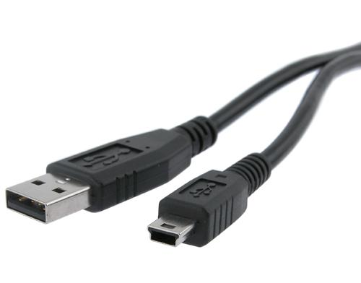

Before You Start
Make sure you have charged the device for 8 or more hours prior to full use.
It is recommended that you charge for 24 hours; however we know this is not always possible.
Turn over for charging instructions…

Overview
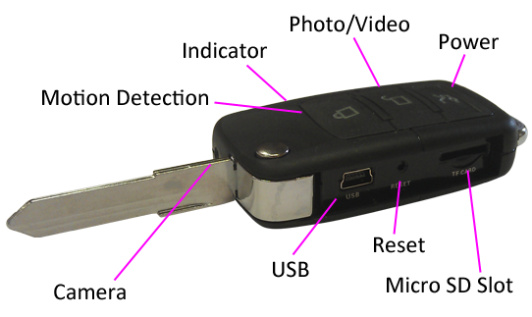
Figure 1
Figure 1 shows the controls that the key fob uses.

Controls

SD Card Slot (TF)
You are able insert a Micro SD card (TF) up to 32GB into this key fob.
When holding the key fob with the buttons on top, make sure the Micro SD card is facing down so the contact points are visible (Figure 2).
Figure 2

USB: Syncing and Charging
Supplied with the key fob is a USB cable which enables you to charge the battery and transfer the files that are saved on the Micro SD Card.

Power

Turn On
Press and hold the Power button until you can see the indicator has turned purple (this should only take 2 or 3 seconds). The indicator will then turn red when ready.

Turn Off
Press and hold the Power button until you can see the indicator start flashing purple, this should take 2-3 seconds only; the indicator will go out and the device is now turned off.

Photo/Video
This button enables you to switch between the camera and video features depending on what you need.

Camera Mode
Turn the key fob on. Once the indicator has turned red then all you need to do is point the key fob in the direction you wish to take a picture of and quickly press the Photo/Video button. The red light will go out momentarily and come back when ready to take the next picture.
When you are done taking pictures you can turn the key fob off or use one of the other features.

Video Mode
Turn the key fob on. Once the indicator has turned red press and hold the Photo/Video button and the indicator will then start flashing red and then go out (this should only take 2 or 3 seconds). It is now recording video.
When you are done recording video quickly press the Power button, the indicator will light up red and stay on solid.
When you are done taking videos you can turn the key fob off or use one of the other features.

Motion Detection Mode
Turn the key fob on. Once the indicator has turned red press and hold the Motion Detection button and the indicator will then start flashing purple and then go out (this should only take 2 or 3 seconds). It is now recording motion activated video.
When you are done recording video quickly press the Power button, the indicator will light up red and stay on solid.
When you are done taking motion activated videos you can turn the key fob off or use one of the other features.

Timestamp Edit
You may need to update the internal clock for the timestamp shown in images and videos.
To do this, you will need to create a Text file with the date and time.
- Plug the camera into your computer by using a USB cable.
- It will appear as a Removable Disk.
- Open the Removable Disk; you might have a folder called DCIM and a text file called “time” already there.
- If you already have a file called “time” then move onto Step 7.
- Right click in the white space and a menu will appear (Figure 3), move down to “New” and select “Text Document”.

Figure 3
- A new Text document will appear (Figure 4) and give you the option to name it, call it “time”.
Figure 4
- Open this time file and write the date and time in the following method:
2010.01.26 10.10.59 (this is example only, use the correct date/time)

- Save and close the file.
- Unplug the camera from the computer and turn it on. The time is now updated.
- Plug the USB Stick back into your computer and delete the time file if still there.

(next page)

Still Struggling?
If you are still struggling to understand how this item works you can get in contact via the following methods.

Recommended
Contact the official stockist through the eBay or Amazon messaging system.

Other
Email: support@ixium.co.uk
Telephone: 0115 9899516

