ixium
DVR Powerbank SP007S
User Manual

Contents
Package Contents 2
Before You Start 2
Overview 3
Controls 3
SD Card Slot (TF) 3
USB: Syncing and Charging 4
Microphone 4
On/Off 4
Video Mode 4
Motion Detection Mode 4
Portable Powerbank 4
Timestamp Edit 5
Still Struggling? 7
Recommended 7
Other 7

Package Contents
- DVR Powerbank Camera SP007S
- USB Cable (USB to Mini USB)
- Backing Plate

Before You Start
Make sure you have charged the device for 8 or more hours prior to use.
It is recommended that you charge for at least 24 hours; however we know this is not always possible.
Turn over for charging instructions…

Overview
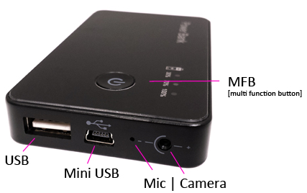
Figure 1
Figure 1 shows the controls that the button camera uses.

Controls

SD Card Slot (TF)
You are able insert a Micro SD card (TF) up to 32GB into this camera.
When holding the camera with the back facing you (make sure the Micro SD card slot is in the top right corner) place the Micro SD card in facing down (Figure 2).

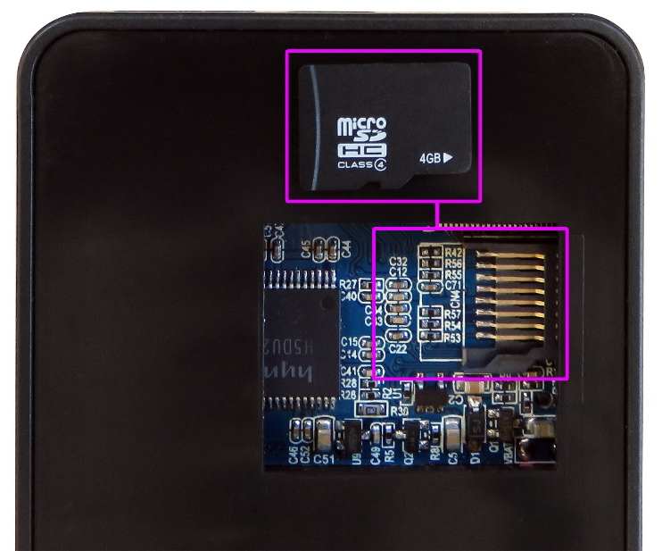
Figure 2

USB: Syncing and Charging
Plug in a Mini USB cable to charge and Sync the files on the Micro SD card. When plugged in the 100% indicator will flash blue.
When plugged in to a computer the camera will appear as a Removable Disk much like a USB memory stick.

Microphone
The microphone works just like any other; it will capture the sound for the videos and audio recorder

On/Off
To turn on simply press and hold the MFB for 3-4 seconds and the 30% indicator will light up red. This is now in standby mode.
To switch the device off press and hold the MFB and the indicator will flash and go out.

Video Mode
Turn the camera on. Quickly press the MFB and the indicator will flash red and go out, this means that it is now recording video.
When you are done recording video quickly press the MFB and the red 30% indicator will come back on solid.

Motion Detection Mode
Press and hold the MFB for 3 seconds, when you let go the 100% blue indicator will flash and then both indicators will go out, this will now record video when the camera detects motion.
When you are done using motion detection mode quickly press the MFB and the red 30% indicator will come back on solid.

Portable Powerbank
Finally you can plug your phone in to the full size USB port to charge. This will help hide the fact it records video and also keep your phone battery topped up.
You do not need to do anything special for this feature to work, simply plug your phone in and away you go.

Timestamp Edit
You may need to update the internal clock for the timestamp shown in images and videos.
To do this, you will need to create a Text file with the date and time.
- Plug the camera into your computer by using a USB cable.
- It will appear as a Removable Disk.
- Open the Removable Disk, you might have a folder called DCIM and a text file called “time” already there.
- If you already have a file called “time” then move onto Step 7.
- Right click in the white space and a menu will appear (Figure 3), move down to “New” and select “Text Document”.

Figure 3
- A new Text document will appear (Figure 4) and give you the option to name it, call it “time”.
Figure 4
- Open this time file and write the date and time in the following method:
2015.01.25 10:10:59 (this is example only, use the correct date/time)
- Save and close the file.
- Unplug the camera from the computer and turn it on. The time is now updated.

(next page)

Still Struggling?
If you are still struggling to understand how this item works you can get in contact via the following methods.

Recommended
Contact the official stockist through the eBay or Amazon messaging system.

Other
Email: support@ixium.co.uk
Telephone: 0115 8716899

