ixium
DVR Pet Camera
User Manual

Contents
Package Contents 2
Before You Start 2
Overview 3
Controls 4
SD Card Slot (TF) 4
USB: Syncing and Charging 4
Microphone 4
On/Off 4
Phone Number Display 5
Video Mode 6
Camera Mode 6
Timestamp Edit 7
Still Struggling? 9
Recommended 9
Other 9

Package Contents
- DVR Pet Camera
- Adjustable Collar
- USB Cable (USB to Mini USB)
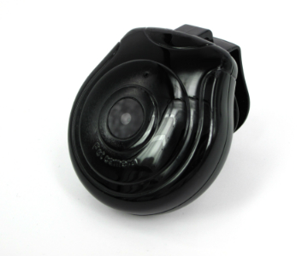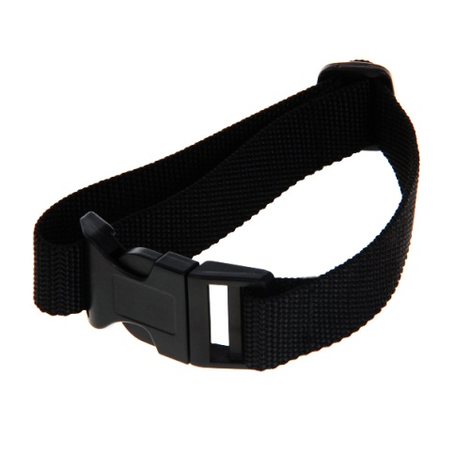

Before You Start
Make sure you have charged the device for 8 or more hours prior to use.
It is recommended that you charge for at least 24 hours; however we know this is not always possible.
Turn over for charging instructions…

Overview
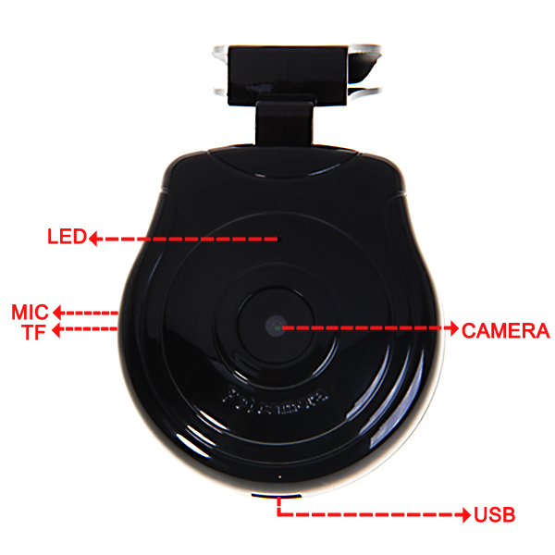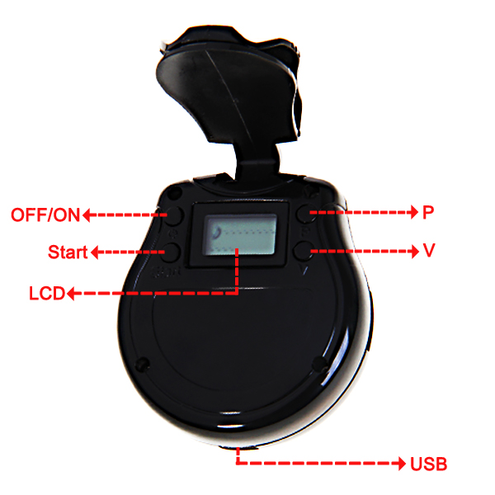
Figure 1
Figure 1 shows the controls that the Pet camera uses.

Controls

SD Card Slot (TF)
You are able insert a Micro SD card (TF) up to 32GB into this camera. The Micro SD Card should click in to place.
When holding the camera with the front facing you, make sure the Micro SD card is facing up (Figure 2).
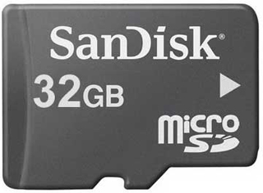
Figure 2

USB: Syncing and Charging
Plug in a Mini USB cable to charger and Sync the files on the Micro SD card. When plugged in the indicator will light up red.

Microphone
The microphone works just like any other; it will capture the sound for the videos and audio recorder

On/Off
To turn the camera on simply press and hold the On/Off button for 1-2 seconds and the LCD screen will illuminate and the full display will appear to indicate the device has been turned on.
When the device has no SD card in it will display “NO-OO” on the LCD screen as highlighted in Figure 3.
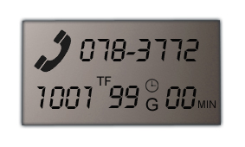
Figure 3
To switch the device off press and hold the On/Off button for 1-2 seconds, the LCD screen will illuminate and then go out and should now only display your phone number. Your phone number will be displayed even when off.

Phone Number Display
You will need to update the internal memory to display your phone number on the LCD screen.
To do this, you will need to create a text file with your phone number in.
- Plug the camera into your computer by using the USB cable.
- It will appear as a Removable Disk.
- Open the Removable Disk, you might have a folder called DCIM and two text files called “time” and “TEL” already there.
- If you already have a file called “TEL” then move onto Step 7.
- Right click in the white space and a menu will appear (Figure 4), move down to “New” and select “Text Document”.

Figure 4

- A new Text document will appear (Figure 5) and give you the option to name it, call it “TEL”.
Figure 5
- Open the text file and enter your phone number in the following format;
078-37716920

- Save the file and close.
- You can now unplug the camera from the computer and switch it on. Your phone number will now be displayed on the LCD screen.

Video Mode
Turn the camera on. The LCD screen will display “00” as highlighted red in figure 6.
Figure 6
Press the “V” button to choose how long you would like to cycle record for i.e. 3mins. Press the start button to start recording videos. The clock (highlighted blue, figure 6) will start flashing to confirm that the device is working.
To stop recording videos simply turn the camera off.

Camera Mode
Turn the camera on. The LCD screen will display “00” as shown in figure 6. Press the “P” button to choose how long you would like to cycle record for i.e. 20secs. Press the start button to start recording taking photos. The clock (highlighted blue, figure 6) will start flashing to confirm that the device is working.
To stop capturing photos simply turn the camera off.

Timestamp Edit
You may need to update the internal clock for the timestamp shown in images and videos.
To do this, you will need to create a text file with the date and time.
- Plug the camera into your computer by using the USB cable.
- It will appear as a Removable Disk.
- Open the Removable Disk, you might have a folder called DCIM and two text files called “time” and “TEL” already there.
- If you already have a file called “time” then move onto Step 7.
- Right click in the white space and a menu will appear (Figure 5), move down to “New” and select “Text Document”.

Figure 5
- A new Text document will appear (Figure 6) and give you the option to name it, call it “time”.
Figure 6
- Open this time file and write the date and time in the following method:
2010-01-26 10:10:59 (this is example only, use the correct date/time)

- Save and close the file.
- Unplug the camera from the computer and turn it on. The time is now updated.
- Plug the USB Stick back into your computer and delete the time file if still there.

(next page)

Still Struggling?
If you are still struggling to understand how this item works you can get in contact via the following methods.

Recommended
Contact the official stockist through the eBay or Amazon messaging system.

Other
Email: support@ixium.co.uk
Telephone: 0115 8716899

