ixium
Mini DVR Camera “Gum”
User Manual

Contents
Package Contents 2
Before You Start 2
Overview 3
Controls 3
SD Card Slot (TF) 3
USB: Syncing and Charging 3
Microphone 4
On/Off 4
Video Mode 4
Camera Mode 4
Audio Mode 4
Timestamp Edit 5
Still Struggling? 7
Recommended 7
Other 7

Package Contents
- DVR ‘Gum’ Camera
- USB Cable (USB to Mini USB)
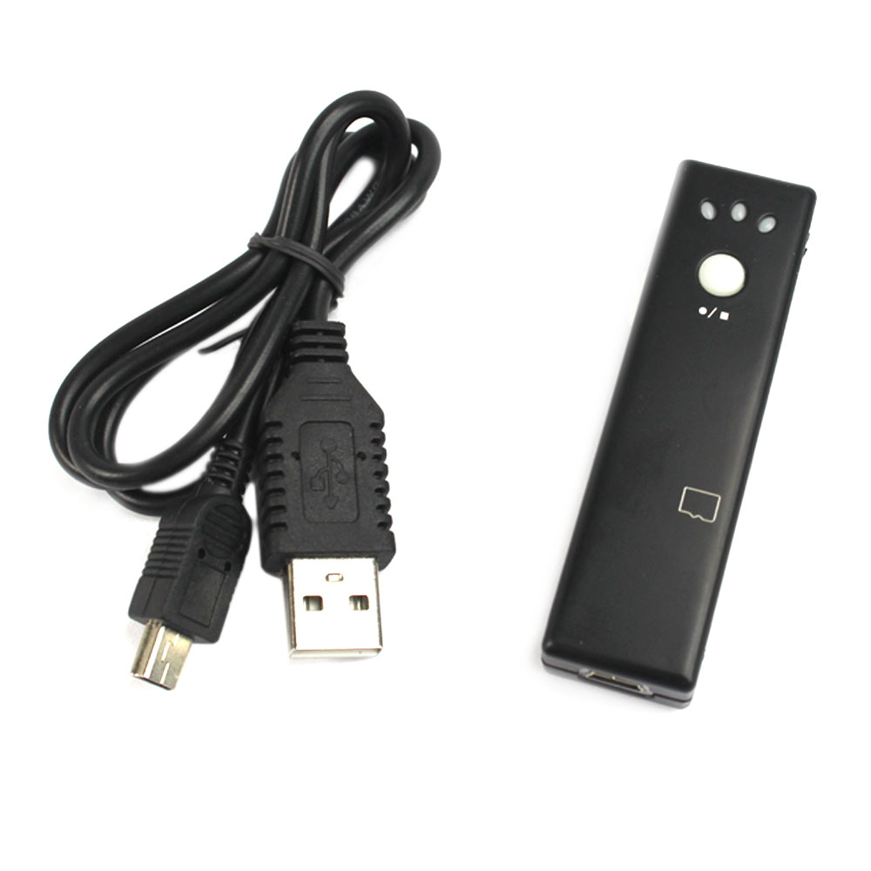

Before You Start
Make sure you have charged the device for 8 or more hours prior to use.
It is recommended that you charge for at least 24 hours; however we know this is not always possible.
Turn over for charging instructions…

Overview

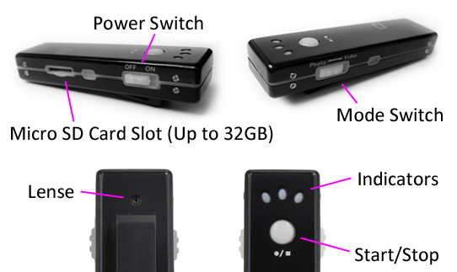
Figure 1
Figure 1 shows the controls that the mini camera uses.

Controls

SD Card Slot (TF)
You are able insert a Micro SD card (TF) up to 32GB into this camera.
When holding the camera with the capture button facing you, make sure the Micro SD card is facing down so the contact points are visible (Figure 2).
Figure 2

USB: Syncing and Charging
Supplied with the mini camera is a USB cable which enables you to charge the battery and transfer the files that are saved on the Micro SD Card.

Microphone
The microphone works just like any other; it will capture the sound for the videos and audio recorder

On/Off
To turn on make sure the power switch is set to on and then press and hold the capture button for 1-3 seconds; the green indicator will light up. Wait until the blue or red indicator lights up and you are ready to use the camera.
To turn the device off flick the power switch to the off position and all indicators will go out.

Video Mode
Turn the camera on. When on make sure the mode switch is set to video (blue indictor should be on solid). Quickly press the capture button and the device will start recording video. The blue indicator should now be flashing.
When you are done recording video quickly press the capture button and the blue indicator will come back on solid.
You can turn the camera off or use one of the other features when done taking videos.

Camera Mode
Turn the camera on. When on make sure the mode switch is set to photo (red indictor should be on solid). Quickly press the capture button and the device will take a picture. The red will go out and come back on when ready to take the next picture.
You can turn the camera off or use one of the other features when done taking photos.

Audio Mode
Turn the camera on. It does not matter whether you are in video or photo mode for this part. Press and hold the capture button for 2-3 seconds and the red indicator will start flashing, this is now recording audio.
When you are done recording audio quickly press the capture button and the red or blue indicator will come back on solid.
You can turn the camera off or use one of the other features when done taking audio.

Timestamp Edit
You may need to update the internal clock for the timestamp shown in images and videos.
To do this, you will need to create a Text file with the date and time.
- Plug the camera into your computer by using a USB cable.
- It will appear as a Removable Disk.
- Open the Removable Disk; you might have a folder called DCIM and a text file called “time” already there.
- If you already have a file called “time” then move onto Step 7.
- Right click in the white space and a menu will appear (Figure 3), move down to “New” and select “Text Document”.

Figure 3
- A new Text document will appear (Figure 4) and give you the option to name it, call it “time”.
Figure 4
- Open this time file and write the date and time in the following method:
2010.01.26 10.10.59 Y (this is example only, use the correct date/time)
2010.01.26 10.10.59 N (Y to display timestamp, N to not display timestamp)
- Save and close the file.
- Unplug the camera from the computer and turn it on. The time is now updated.
- Plug the USB Stick back into your computer and delete the time file if still there.

(next page)

Still Struggling?
If you are still struggling to understand how this item works you can get in contact via the following methods.

Recommended
Contact the official stockist through the eBay or Amazon messaging system.

Other
Email: support@ixium.co.uk
Telephone: 0115 9899516

