ixium
iXium XN9 Listening Bug
User Manual

Contents
Package Contents 2
Before You Start 2
Overview 3
Operation 3
Basic Listening Function 3
Call Out Function 3
Enable 3
Disable 3
Sensitivity Adjustment 4
SMS Notification 4
Enable 4
Disable 4
Sensitivity Adjustment 4
GPS Tracking 4
Battery Level Check 4
Still Struggling? 5
Recommended 5
Other 5

Package Contents
- iXium XN9 Listening Bug
- USB Cable
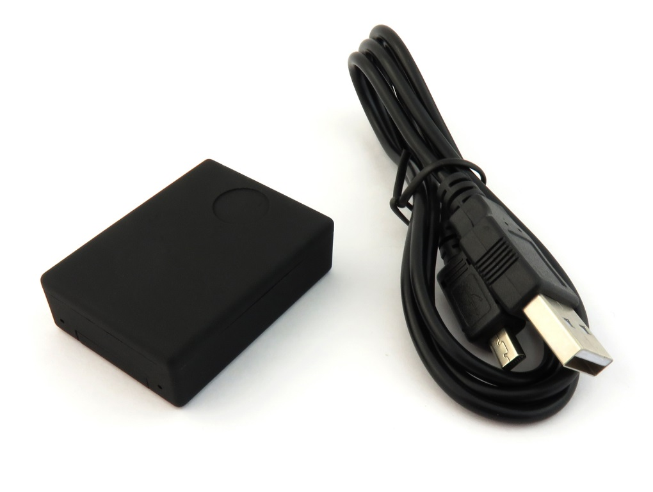

Before You Start
Make sure you have charged the device for 4 or more hours prior to use.
It is recommended that you charge for at least 6 hours; however we know this is not always possible.
Turn over for charging instructions…

Overview
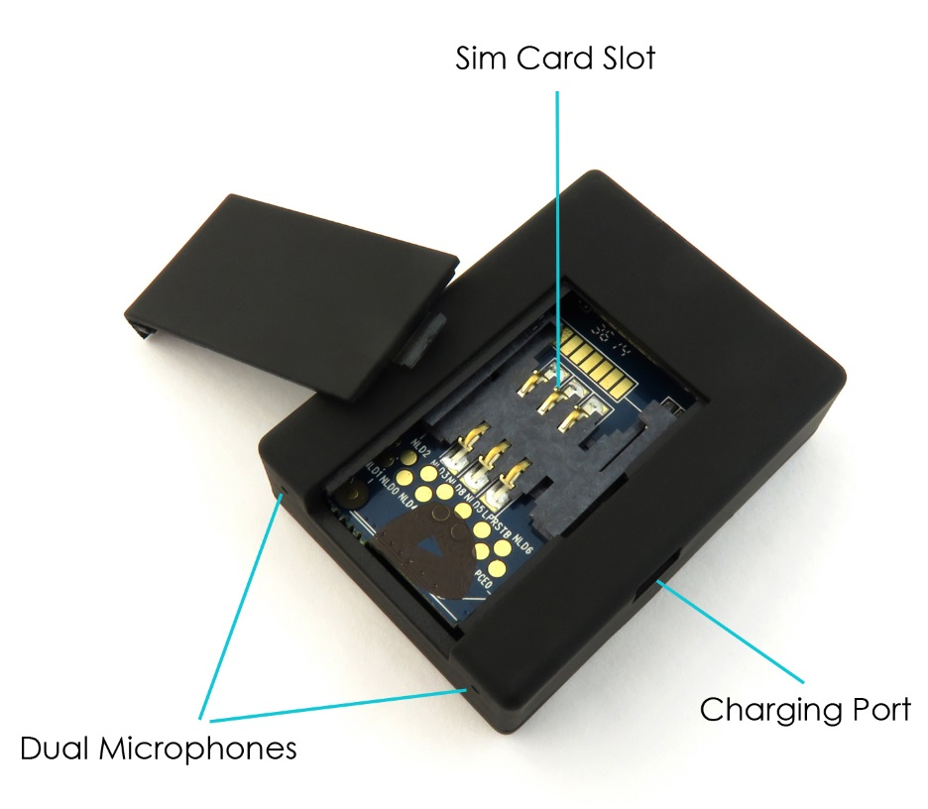
Figure 1
Figure 1 shows the main features of the XN9 listening bug. As you can see it uses dual microphones for better sound pickup, includes a charging port on the side and the SIM card slot is located in the back.

Operation

Basic Listening Function
If you would like to hear what is happening around the XN9 listening bug then you can simply call the number of the SIM card that you placed in it. The SIM card does not need any credit on it as it will only be receiving a call.

Call Out Function
The XN9 listening bug can call you if there is any sound above 60DB by default (the volume of the average conversation).
To use this feature you must first ensure that you put in a SIM card with credit on; this could be a pay as you go or pay monthly contract.

Enable
Send a text to the XN9 bug SIM with the code 888; you will receive a text confirming that the Call Out function has been enabled.

Disable
If you wish to disable the Call Out function send the XN9 a text with the code 444; this will again send you a confirmation text to say it has been disabled.

Sensitivity Adjustment
The sensitivity level for the Call Out function can be adjusted. To adjust the sensitivity you send the XN9 a text with 888#..# (replace .. with preferred decibel); the XN9 bug can activate between 10 – 100 decibels. If you were wanting the bug to call you at 70DB instead of 60DB then you would send it a text of 888#70#. If you wanted the XN9 activation level more sensitive you would send it a text 888#40# which would change it to 40 decibels.

SMS Notification
Similar to the Call Out function you can set the XN9 listening bug to text you a whenever there is any sound above 60BD.

Enable
Send a text to the XN9 bug SIM with the code 777; you will receive a text confirming that the SMS notification function has been enabled.

Disable
To cancel the SMS notifications you send the text 444 to it just as you would do to cancel the Call Out function.

Sensitivity Adjustment
The sensitivity level can be adjusted the same way as you would change the sensitivity to the Call Out function; text 777#..# instead of 888#..#. Again replace .. with the decibels that you wish the bug to activate.

GPS Tracking
If you put the XN9 listening bug in to a car or something that will get moved about you can use it to gather GPS data. Text DJ (in capitals) to the XN9 and it will text back with both Latitude and Longitude coordinates enabling you to find out where the bug is.

Battery Level Check
The XN9 does not have a screen or any kind of indicator that will tell you how much the battery life is remaining; text 666 and it will respond with one of the following replies:
- Tracker Battery Full
- Tracker Battery Half Full
- Tracker Battery Low

Still Struggling?
If you are still struggling to understand how this item works you can get in contact via the following methods.

Recommended
Contact the official stockist through the eBay or Amazon messaging system.

Other
Email: support@ixium.co.uk
Telephone: 0115 8716899

