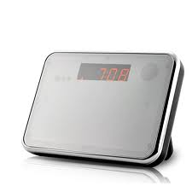Digital Video Recording Mirror Alarm Clock

Please read! This item is shipped with a small piece of plastic between the battery and the contacts. Please ensure you remove these and reinsert the batteries before use.
Included CD: The included CD contains files and drivers that may be of use when using the device in Webcam mode etc. If there are any issues with the included disc, the contents are also available from the following location:
http://www.mobilesandeverything.co.uk/image_server/desktopmirrorclock.zip

Introduction:

These instructions will show you how to use the product. It provides the necessary information related to the product such as operating and handling instructions. It is recommended that you read the instructions fully and carefully before operation. Please keep the instructions safe for future reference!

Digital Alarm Clock Features & Settings

Function Features:
- Time display: displays current time, day, month and year
- Alarm & delay: set alarm time and alarm delay time (1~60mins)
- Talking Clock: a voice speaks out the current time
- Temperature display: detects and displays the environment temperature
- Nature Sounds Play: adjustable play time (10~60mins)

Function Settings:
Time Settings:
- In time display mode press the “SET” button to enter the ‘year’ setting. The screen displays “2010” and flashes. Press buttons ‘up’ and ‘down’ to select the correct year
- Press button ‘SET’ again to save the year and enter the ‘month-day-hour-minute’ setting. Press buttons ‘up’ and ‘down’ to select the correct values and press ‘SET’ to save that value and move onto the next
- When date and time settings are finished press the ‘MODE’ button to quit time settings and the screen returns to the main clock display

Alarm Settings:
- In time display mode press the “Mode” button to enter the alarm clock settings. The screen displays “--:--“ and is in Alarm settings mode.
- Press “SET” to enter the ‘hour’ setting. Press the ‘up’ and ‘down’ buttons to change the value and press “SET” again to save the setting and move to ‘minute’. Enter the correct minute and press “SET” to move to alarm delay time (1~60mins). Select your value and press “SET” again to move to the alarm music setting. Select your value and press “SET” again to return the display to “--:--“ (Alarm settings mode).
- In ‘Alarm Settings Mode’ press the ‘up’ button to cycle through the alarm clock modes :-

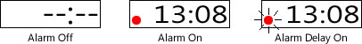

- Press the “Mode” button to return the clock to time display mode.

Display Settings:
- In time display mode press the ‘up’ button to switch between 12H/24H mode.
- In time display mode press the ‘down’ button to switch between Celsius and Fahrenheit

Talking Clock and Nature Sound Functions
- In time display mode press the ‘talk’ button to make the clock speak the current time
- In ANY mode press the “TIME” button to start and set nature sound play time (10~60mins)
- In ANY mode press the “TALK” button and hold it down for 2 seconds to enter the nature sound play mode. It will play the selected nature sound for the duration set in the ‘nature sound play time’ until the counter hits 00:00
In Nature Sound Play Mode press the “TALK” button to pause and press it again to move onto the next sound. Press the “MODE” button to quit the Nature sound playback.

Digital Video Recording Features & Settings

This product includes a digital video recorder and a TF/MicroSD card reader which can read/write on up to 32GB MicroSD memory cards. The camera can record video at 30FPS and a resolution of 1280x960 and combines video and audio. It can be used to record audio only, and also take still image captures at the press of a button. With its built in high capacity battery it can record continuously for up to 12 hours video or 25 hours audio. Video recording can be initiated at the press of a button or via the built in motion detection mode.
All in all this product is a digital video recorder, photo taker, motion activated video capture device, MicroSD card reader and it can even be used as a webcam!

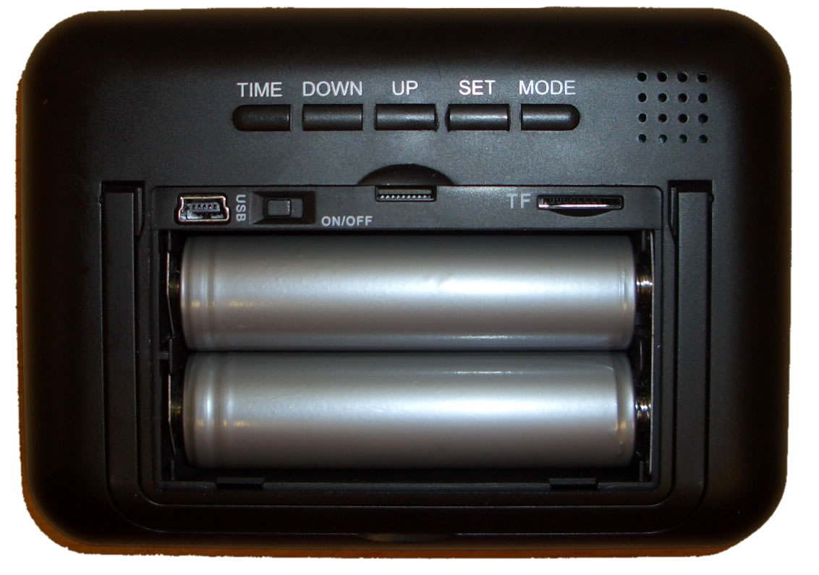

Function Features:
- Open the cover on the back of the clock. Ensure the switch is in the ‘OFF’ position and insert your MicroSD memory card into the slot provided. The metal connectors on the memory card should be facing UPWARDS as you insert the card. Flip the switch to the “ON” position.
- Press the 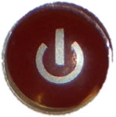 button on the remote control. The blue LED indicator turns on (underneath clock readout, bottom left) to indicate that the video recorder is in “standby”.
- Press the 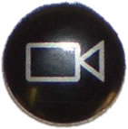 button on the remote control to begin recording video. The blue LED will flash 3 times and then start recording and go out. Press the button again to stop recording and return to “standby”.
- Press the 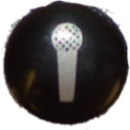 button to start recording audio only. The blue LED will flash twice and then go out to indicate it has started recording. Press the button again to stop recording and return to “standby”.
- Press the 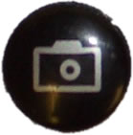 button to take a photo. The blue LED will go out and come back on to indicate a photo has been taken.
- Press the 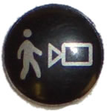 button to begin motion detection mode. When the device detects motion it will activate a 3 minute recording session. Whilst motion continues the 3 minutes is constantly refreshed. When motion ceases, the 3 minute countdown begins and recording stops when it reaches 0. Press the button again at any time to exit motion detection mode and return to “standby”.
- Press the button to turn the device off and the blue LED will go out.

USB Card Reader Function:
- With the clock in the on/standby status, connect it to your computer via the included USB cable. Press the button and the blue LED will come on. Some moments later your computer will recognize that a USB disc has been inserted. You can now access the memory card in the clock like any other USB disc. Press the power button again to turn the clock off before disconnecting from your computer.
WARNING – Do not disconnect the clock whilst reading/writing files to/from the inserted memory card.

Web Camera Function:
- Install Web Camera Drive Software from the included CD or from the available download location.
- With the clock in the on/standby status, press the button and the blue LED will come on. Now connect it to your computer via the included USB cable and your computer will detect and install the device as a webcamera. You can now use it with your favourite webcam apps, such as Skype, MSN Messenger and many more!

Charging:
- Move the toggle switch to the “OFF” position. Plug in the USB cable and connect it to your computer. A RED LED will come on to indicate that the device is charging. When the battery is full the LED will turn off. The LED can be difficult to see due to it being covert. Do not take this as not charging!
Please Note: When connected to your computer to charge, the switch must be in the ‘OFF’ position otherwise your computer will detect it as a disc drive as in “USB Card Reader” mode. When in the “OFF” position your computer MAY report an unknown device. This message can be ignored.

Reset:
- If the device stop responding or otherwise behaves in a manner which is unusual, you can reset the device by moving the switch to “OFF” and then back to “ON”.

Low Power Warning:
- When the device is low on power, the blue LED indicator will flash continuously to alert you that it needs to be placed on charge. If the power runs out whilst the device is recording, it will save and close the current file before powering itself down.

Important Notes:

- We Strongly Recommend copying any recorded files off the memory card and onto your computer before initiating playback. This is because the files are encoded at quite a high bitrate and the transfer between USB discs and your computer is not fast enough to play the video smoothly.
- If your videos stutter when playing make sure you have followed the above instructions and copied the files off your memory card and onto your computer before attempting to play them back.
- We Recommend using Media Player Classic OR VLC Media Player to play back the videos.

To Change The Embedded Video Time:
The time/clock shown in the video is separate to the clock on the front of the camera and cannot be changed by modifying the main clock. If you’d like to change the embedded clock settings please follow the instructions below.
PLEASE NOTE: Some of the files included on the CD allow you to change video settings. We strongly recommend you leave these alone as changing the wrong setting may result in your videos being distorted or unwatchable.

- If you have not done so already, run the program called “STK03N.exe” from the included CD or download. Follow the onscreen instructions to install the software and drivers. If you get a window popup which gives you the option to “Install” or “Don’t Install”, make sure you click “Install”. You have now installed the webcam drivers and the image download utility.
- Make sure the clock is on (ie you can see the red digits on the front of the clock).
- Insert a memory card with free space. THIS STEP IS IMPORTANT EVEN THOUGH YOU ARE NOT RECORDING ANY VIDEOS AT THIS TIME!
- Move the switch in the back of the clock to the “ON” position
- Using the remote, press the power button so the BLUE light comes on in the front of the clock.
- Connect the included USB cable to your computer and insert the other end into the socket in the back of the clock.
- A few moments later the “Image Download Utility” will open. If you have no videos or images on the inserted memory card the program will close automatically after approx. 15 seconds, otherwise it will remain open. You can close it or leave it open for later use.
- Run the program called “STK03NC.exe” from the included CD or download.
- A small window will open with a number of icons across the top.
- Click the icon which resembles a screwdriver+spanner
- In the window that opens, look for and click the “CLOCK” tab
- Choose and enter the appropriate time and date details.
- When you are happy with the details you have entered, click the button marked “SET CLOCK”
- The time & date for the embedded clock display are now set.
- Click the “OK” button to close the current window.
- Click the icon that resembles a power lead to close the application
- You can now disconnect the clock.

Please Note: If you remove the main batteries and power the clock down fully, it can lose the embedded clock settings. If this is the case just follow the instructions above to change the time and date again.
We Strongly advise against changing any of the other settings available with the included software applications. They provide low level access to the device and any changes can adversely affect the recording ability and quality of your device.

Problems / Faults / Questions / Etc
Here at Gadget Express™ we pride ourselves on sourcing high quality items at low prices and passing the savings on to you. We don’t look for massive profits per item, but massive sales through the continued provision of high quality items and top quality customer service. If for any reason your product develops a fault, we want to hear from you so that we can put it right! We provide 3 methods of simple and efficient communication so that any issues can be dealt with quickly and resolutely.

- Ebay Messaging: log into Ebay, goto the listing you purchased the item from and click “Contact Seller”. You will be taken to our FAQ (frequently asked questions) page. If you do not find your answer there you will find a “Contact Seller” button in the bottom left corner and this will allow you to send us a message directly.
- Live Chat: log into Ebay, goto the listing your purchased the item from and you will see a “LIVE CHAT” icon at the top of the listing. If we’re “ONLINE” click the icon to initiate a live chat session with one of our support representitives.
- Telephone: contact us directly by calling our offices on 01159 899516

Item Specifications:

Pixel Count | 5 Megapixel CCD
Resolution | 1280 x 960
Video Format | AVI
Maximum Frame rate Capability | 30 FPS
Vision Angle | 120º
Induction Photography | 6 Meters Straight line
Minimum Illumination | 1 LUX
Battery Capacity | 4800mAh
Continuous Recording Time | Over 12 Hours
Remote Operating Distance | 18m
Scope for sound Recording | 40m squared
Power consumption | 130mA / 3.7V
Storage temperature | -20 to 80ºC
Working temperature | -10 to 60ºC
Working Humidity | 15 to 85% RH
Memory Card compatibility | MicroSD Cards ONLY
Maximum capacity of memory card | 32 Gigabytes maximum
Recommended Player Software | VLC Player, Media Player Classic
USB Interface | USB 1.1/2.0
Operating System Compatibility | Win 2000 / XP / Vista32 / Win 7
Time of video / consumed storage | 1GB = approx 40 mins
Charging Time | Approx 8 hours

