Coat Hook Spy Cam DVR Instructions

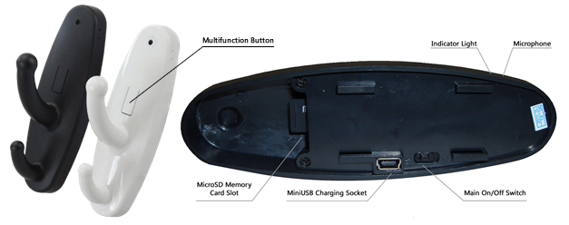

Introduction:
Thank you for purchasing this discreet Clothes Hook DVR Camera. It has been uniquely designed to be portable and easy to use so that it can be applied quickly to any area.

IMPORTANT NOTE:
- This device requires a MicroSD Card to function (not included). Please ensure you have inserted a MicroSD card with some free space before turning the device on. If no card is inserted the indicator will come on solid, then flash nine times and go out again.

- No CD is included with this item. No software is required in order for this device to function correctly. Once you have recorded your videos/photos you only need connect the device to your computer using the included MiniUSB cable and the memory card will show up in “My Computer” like any normal USB Stick and can be accessed in the same way. We strongly recommend you copy any video files off the memory card and onto your computer before attempting to play them.

Charging the Device (Essential Before First Use)
To charge the device, ensure the switch on the back of the item is in the “OFF” position. Connect the included USB cable into a spare USB port on your computer or a USB mains charger, and connect the other end to the small USB port on the back of the Coat Hook.
The Indicator light will start to alternate between Green and Off (2 second cycle). When the item is fully charged, the light will stop flashing and go out completely.

Please Note: This is the same process as the one to use the item as a card reader. When connecting the cable to your computer you may be presented with a popup allowing you to view the contents of the MicroSD card if one is inserted. You may use the item to view your files whilst the item is charging without any negative effects.

To Turn Coat Hook ON:
To turn the Coat Hook Camera on, first ensure that a MicroSD memory card with free space has been inserted into the slot in the back. Next, move the switch on the back of the coat hook into the “ON” position.
Press and hold the Multifunction button on the front. After approx. 1 second the green indicator light will come on, flicker once and then stay on solid. The device is now ON and in standby mode.

To Record Constant Video:
When the Green light is on Solid the device is in Standby mode and is ready to record. Press the multifunction button on the front ONCE (like a single mouse click). The Green light will flicker briefly and go out. The Coat Hook DVR is now recording video and Audio to the inserted memory card. Whilst the camera is record, the light will stay off. To stop the recording, press the multifunction button again. The Green indicator light will come back on solid and the device is back in Standby.

To Record via Motion Detection:
When the Green light is on solid, the device is in Standby mode and is ready to record. Press the multifunction button on the front TWICE (like a double mouse click). The Green light will flash 4 times and then go out completely. The Coat Hook DVR is now in motion detection mode and will only record when it detects motion in its field of view. Please note – 1) the motion detection is pixel based, not IR. 2) Whilst in motion detection mode, the light will stay out at all times. It will not flash when it detects motion, nor will it flash when it records. The light will stay out until the button is pressed again to return the device to standby mode.

To View Your Videos/Photos/Audio:
To view the media you have recorded remove the microSD card. Insert the card into an appropriate reader connected to your computer and it will act as any USB Thumb drive would. A removable disc drive will appear and your files are stored on that drive inside a folder named “Video”.

You can also use the Coat Hook itself as a card reader. Ensure you have your MicroSD card inserted into the device. Move the switch into the “OFF” position and connect the device to your computer using the included USB cable.
You may get a pop up (depends on your windows version and personal settings) just the same as when you use a USB memory stick. If you do not get a pop up you can access the “Removable Disc” from “My Computer” Your files will be inside the “Video” folder.

We strongly recommend you copy any videos off the memory card and onto your computer before you play them due to the transfer limits of USB connections. If you play your videos straight off the memory card you may experience stutter.

Please Note: There is no CD or software specifically required to make this item work.

