MINI DV Camera Lighter User Manual
Product Info
- Mini camera in the shape of a Gas Lighter
- USB Extension Cable
- Supports PC camera for Skype MSN etc.
- Supports AVI video format 30 fps at 720 x 480 resolution
- Supports 1280 x 960 Photo resolution
- Support USB1.1 and USB2.0.
- Support up to 16GB T-flash card.(Not Supplied)
- Built-in lithium ion battery with up to two hours recording time and two hours thirty minutes standby time.
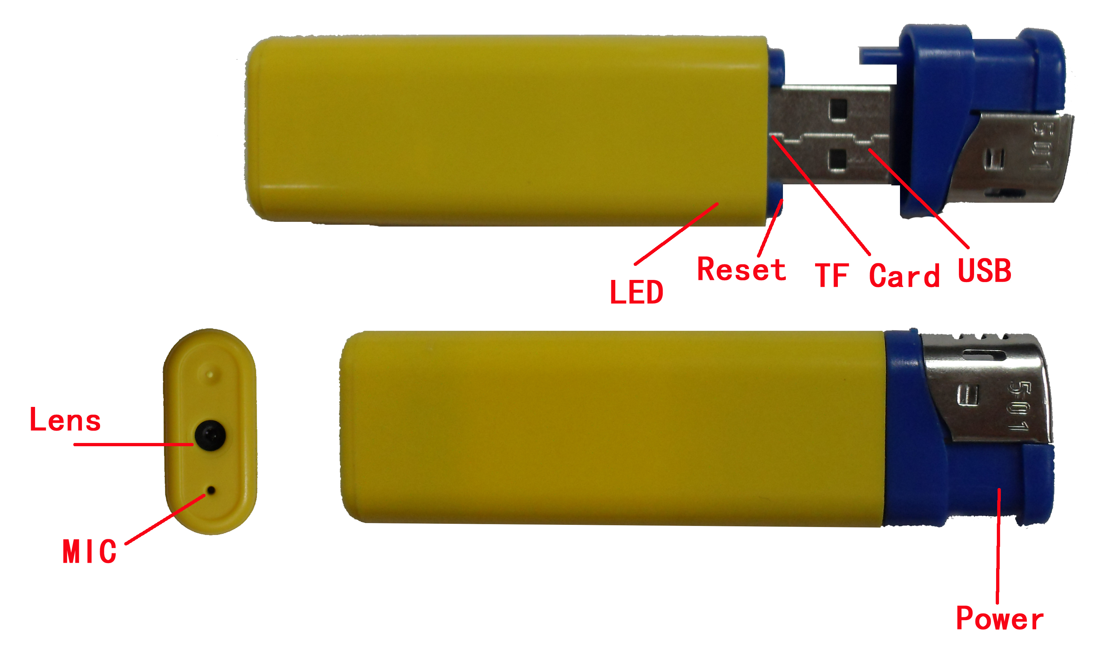
1. Charging
To Charge the Lighter camera, connect it to the computer using the USB cable provided.
When charging, the light blinks slowly, and is fully charged in approximately two hours.
Notice: when battery power drops below 1% the lighter camera will power down.
2. Power On + Sound Activated Recording
Please confirm that you have inserted a Micro SD card in the slot (up to 16GB).
Press power button gently for 2 seconds until the indicator light begins to glow as the camera powers up. The light will come on, and then go out shortly after indicating that the device is now recording in SOUND ACTICATION MODE. If the sound level exceeds 60dB, recording will start for a minimum of 1 minute and stop 1 minute after no further sound is heard. There will be no visible sign that the lighter is recording. Press the button ONCE in order to end SOUND ACTICVATION MODE. The light will come back on, flash a few times to save videos if necessary, and then go solid to indicate that the device is now in standby mode.
3. Take Photo
Whilst in standby mode (light glowing solid) press the button and let go to take a photo, the light will go out and come back on to confirm the photo has been saved. The file resolution for photos is: 1280 x 960
4. Standard Video Recording
This can only be done whilst the lighter is in standby mode.
Whilst In standby mode (light glowing) press and hold the button only until the light begins to flash (only about 1 second!) and then let go. The light will continue flashing to confirm the video is now recording. To stop and save the video press the button again. Recording stops and the light comes back on. The file resolution for video is 720 x 480. Fps: 29~30fps.

5. Power Off
Whilst in video/ photo standby mode (light glowing) hold the button down. You will see a the light flash and eventually go out. Once it has gone out you can let go, and the device is powered down.

Please Note:
a. Please make sure a T-flash (Micro SD) card has been inserted, if not, it will power off automatically after 15 seconds.
b. The maximum capacity of T-flash card that can be used is 16GB.
c. Saving the file takes a small amount of time, so please don’t press the button continuously, as this may save an incomplete file.
d. When you make a video, please keep the lighter as still as is possible under the circumstances and use sufficient illumination to ensure that the video is as clear and crisp as it can be.

6. Time set
The device comes with a feature which embeds the current time and date on to your captured photos and videos. To set the time and date of the device, please follow the instructions below.
1. Insert the lighter+SD card into a USB port or Place the SD card into your computers card reader.
2. Make sure you are on the “root” (top level) folder of the SD Card.
3. (If it does not already exist) Create a new file with the name TAG and extension .txt (TAG.txt)
4. Open the file and write the following information:
2012-12-25 14:00:00
This example would set the unit to 2pm on the 25th of December 2012. You can customise the information to represent the current time in your area. Save the changes to the file (TAG.txt) and place the SD card back into the Camera device. When you next turn on the device it will automatically read the TAG.txt file and change its internal date and time settings to the information you have provided.

7. Auto-power off function
The MINI DV will save file and turn off automatically in the following circumstances:
a. When you shoot video without enough power, the file will be saved automatically, and then auto-power off.
b. When the disk space of camera lighter is full, the file will automatically save and the unit will power down.

8. Connecting computer
You can connect the lighter camera to the USB port of your computer to view the photographs or video. You can also use it as a memory stick. You may need to press the reset button when you have unplugged it from your computer to return it to camera mode.
Notice:
a. If your computer does not identify the camera within 30 seconds remove the camera from the USB socket press the reset button and insert it again.
b. It is better to copy the video files to your computer before playing them. If you play them back directly from the memory card they may stutter or pause.

9. PC Camera
If you wish to use the lighter camera as a web cam please contact us and we will supply the drivers.

10. Reset
If the Camera Lighter starts to act unusually, press the Reset button with a paper clip.

11. Notice
Please follow the laws of your country. Do not use it illegally.

